**ANIMATED SEARCH BAR**

**USING HTML AND CSS**



**Table of contents**

**First let’s create the skeleton of the ui** **2**

Markup of search bar 2

**Let’s add styling into the ui** **2**

Basic styling 2

Center everything and basic styling in body 3

Styling input type text .searchfield 3

We want to expand width of search field on focus let’s write css for that 4

Let’s write css for creating search icon 4

Add following css code in .searchfield class 5

Add below css code to .searchfield:focus 7

Change cursor pointer on hover .searchfield 7

Let’s change the search icon into cancel icon very similarly how 8

we created search icon using css pseudo classes on focus .searchfield 8

Cursor pointer on hover .search ( on cancel icon ) 9

**Congratulation we have successfully** **10**

**created cool animated search bar 🥳** **10**

**— The End —** **10**

Was it useful 🤔 let me know on instagram 10

— Get Source Code Here — 10

— Get Source with code comment — 10

# **First let’s create the skeleton of the *ui***

## Markup of search bar

| <**input** type="text" class="searchfield" /> <**div** class="search"></**div**> |
| --- |

In above html code we created one **text** input type for **search bar** and **one div** with the

class name *search* we’ll use that div for creating **search icon and cancel icon** using css



# 

# **Let’s add styling into the ui**

## Basic styling

| * { margin: 0; padding: 0; box-sizing: border-box; }  html, body { width: 100%; height: 100%; } |
| --- |

## 

## Center everything and basic styling in body



| body { display: flex; justify-content: center; align-items: center; min-height: 100vh; background-color: #111; font-family: "Ubuntu", sans-serif; } |
| --- |

## Styling input type text .searchfield

| .searchfield { /* positioning */ position: absolute; /* typography */ font-weight: 600; font-weight: bolder; /* box model */ padding: 0 80px 0 20px; margin: auto; top: 0; right: 0; bottom: 0; left: 0; width: 50px; height: 50px; outline: none; border: none; z-index: 5; letter-spacing: 0.1em; /* visuals */ background: #fff; color: #111; text-shadow: 0 0 10px #ccc; border-radius: 30px; box-shadow: 12px 13px 25px 0 #111, 8px 9px 25px 0 rgba(0, 0, 0, 0.2); transition: all 1s; } |
| --- |

In above code we written css for styling **searchfield** see result below 👇



### We want to **expand width** of ***search field*** on **focus** let’s write css for that

| .searchfield:focus { width: 300px; cursor: text; } |
| --- |



### Let’s write css for creating **search** icon

| .search { position: absolute; margin: auto; top: 0; right: 0; bottom: 0; left: 0; width: 50px; height: 50px; background: #fff; border-radius: 50%; transition: all 1s; z-index: 4; } |
| --- |

But there is no changes see below 👇



To see **search icon** we have to describes ***opacity 0*** to make

**searchfield** transparent in *.searchfield*

### Add following css code in **.searchfield** class

| opacity: 0; |
| --- |

Now we can see one small circle



We want **search icon** inside this *circle div* let’s write css for that

| .search::before { content: ""; position: absolute; margin: auto; top: 10px; right: 8px; bottom: -5px; left: 22px; width: 12px; height: 2px; background-color: #111; transform: rotate(45deg); } |
| --- |

| .search::after { content: ""; position: absolute; margin: auto; top: -5px; right: 0; bottom: 0; left: -5px; width: 15px; height: 15px; border-radius: 50%; border: 2px solid #111; } |
| --- |

In above css code we created search icon using **::before** and **::after** pseudo classes

But there we have one problem when we click to focus on **.searchfield** to **expand width** of **.searchfield** it’s not expanding

See here 👉

**.Searchfield** not expanding because in above css code we described the **opacity 0** to **.searchfield** for making **searchfield** transparent now we have to describe opacity

to 1 on focus .searchfield to show and expand search field

### Add below css code to **.searchfield:focus**

| opacity: 1; |
| --- |

### Change cursor pointer on hover **.searchfield**

| .searchfield:hover { cursor: pointer; } |
| --- |



☝️ As you can see above it’s working as expected at this step everything is

rights let’s go to the next step and create **cancel icon** in *right* side of **search bar**

If you remember above we created**search icon** in **.search** div now we’re going to use

that same div to create **cancel icon too ,** for this moment let’s give **right to -240px**

to align search icon in **right side** of **search** bar on *focus* ***.searchfield***

| .searchfield:focus~.search { right: -240px; background: transparent; z-index: 6; } |
| --- |



### Let’s change the **search icon** into **cancel icon** very similarly how

### we created *search icon* using css *pseudo classes on focus .searchfield*

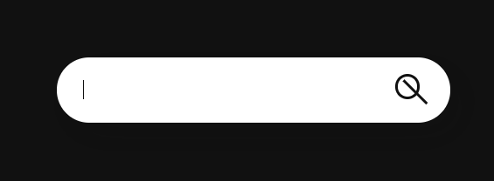

| .searchfield:focus~.search::before { top: 28px; left: 15px; width: 25px; height: 2px; bottom: 25px; } |
| --- |

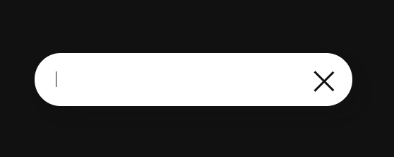

| searchfield:focus~.search::after { top: 29px; left: -8px; width: 25px; right: -15px; height: 2px; border: none; bottom: 25px; background: #111; border-radius: 0%; transform: rotate(-45deg); } |
| --- |

### Cursor **pointer** on hover **.search** ***( on cancel icon )***

| .search:hover { cursor: pointer; } |
| --- |



Tutorial written by [sumit](https://www.instagram.com/codingsumit/) Creator of [coding.batch](https://www.instagram.com/coding.batch/)

# 

# Congratulation we have successfully

# created cool animated search bar 🥳

# — The End —

## Was it useful 🤔 let me know on instagram

## — Get Source Code Here —

## — Get Source with code comment —